**Chauhan Abhishek**

* Assignment:
* Module -1: Understanding of Hardware and Its Components
* Which of the following is NOT a component of the CPU?
* ALU
* RAM
* CU
* 1 and 3 both

**Answer - RAM**

**Note- Because RAM is not a component**

**What is the function of RAM in a computer?**

* **Answer - Ram** (random access memory) is to temporarily store data that the computer is currently using, such as the operating system and software programs. RAM is a type of computer memory that can be read and changed in any order, and is usually much faster than other types of storage.
* Here are some more details about RAM:
* Volatile
* RAM is volatile, meaning that data is lost when the computer is turned off. When the computer is rebooted, the OS and other files must be reloaded into RAM.
* Main memory
* RAM is often called a computer’s main memory, and is part of the computer’s primary memory.
* Data access
* RAM allows data items to be read or written in almost the same amount of time, regardless of the data’s physical location.
* Storage
* RAM is different from other storage units like hard disks and solid state drives, which hold permanent information.
* Which of the following is a primary storage device?
* HDD
* SSD
* SD card
* 1 and 2 both

**Answer - 1 and 2 both**

**Note- HDD and SSD both are primary storage device**

* **What is the purpose of a GPU?**
* **Answer -**A graphics processing unit (GPU) has many purposes, including:
* Graphics: GPUs are designed to accelerate the rendering of 3D graphics and other visual effects for consumer devices like computers, smartphones, and gaming consoles.
* Machine learning: GPUs are used in AI and machine learning applications because of their ability to perform parallel operations on large sets of data.
* Video editing: GPUs are used in video editing applications because they can perform mathematical calculations at high speed.
* Scientific applications: GPUs are used in scientific applications because of their ability to perform parallel operations on multiple sets of data.
* High performance computing: GPUs are used in high performance computing (HPC) to accelerate workloads.
* Creative production: GPUs are becoming more popular for use in creative production.
* GPUs are designed to perform the same operation on multiple data values in parallel, which increases their processing efficiency.

* True or False: The motherboard is the main circuit board of a computer

Where other components are attached

Answer - **TRUE**

* True or False: A UPS (Uninterruptible Power Supply) is a hardware

Device that provides emergency power to a load when the input power Source fails.

**Answer – TRUE**

* True or False: An expansion card is a circuit board that enhance the Functionality of a component.

**Answer – TRUE**

* **Explain the difference between HDD and SSD.**
* **SSD HDD**
* More expensive. More Affordable
* Available in terabyte Larger Capacity

Size

* SSD Stand for HDD stand for

Solid State Drive Hard Disk Drive

* Faster. Slower
* Flash memory cheap. Magnetic platter and rotating Disk
* Limited number No specific limitations on write cycles

On write cycles

* **Describe the function of BIOS in a computer system.**
* **Answer -** The Basic Input Output System (BIOS) is a computer’s firmware that performs several functions, including:
* Booting
* BIOS is the first software to run when a computer starts, and it instructs the computer on how to boot up.
* Hardware testing
* BIOS runs diagnostic tests, including the power on self-test (POST), to ensure that the computer’s hardware is working properly.
* Configuring hardware
* BIOS stores hardware settings for the computer’s processor, memory, graphics card, hard disk drives, and other components.
* Managing data flow
* BIOS manages the flow of data between the computer’s operating system (OS) and any attached devices.
* Loading the OS
* BIOS locates the OS on the computer and turns control of the hardware over to it.
* Locating software and drivers
* BIOS locates the software and drivers that interface with the OS once it’s running.
* Complementary metal-oxide semiconductor (CMOS) setup
* BIOS allows users to change hardware and system settings, such as the time.
* BIOS is stored on a small memory chip, called firmware, that’s embedded in the computer’s motherboard. BIOS firmware is non-volatile, meaning that its settings are saved and recoverable even after the computer has been powered off.
* To enter BIOS setup on a Windows PC, you can press a key like F1, F2, F10, DEL, or ESC as soon as the manufacturer’s logo appears, but before the operating system loads.
* **List and briefly explain three input devices commonly used with Computers.**
* Answer - Here are three commonly used input devices for computers:
* Keyboard
* A basic input device with keys for numbers and letters that allows the user to input alphanumeric data. The layout of a keyboard is similar to a typewriter, but manufacturers add extra keys for specific functions.
* Mouse
* A pointing device that allows the user to navigate the computer screen by clicking and dragging the cursor. The user can select icons on the screen by pointing to them with the mouse.
* Scanner
* A device that scans images, text, or documents and converts them into a digital format that can be saved to the computer’s hard drive. It works similarly to a photocopier.
* Identify and label the following components on a diagram of a motherboard
* CPU
* RAM slots
* SATA connectors
* ● PCI-E slot

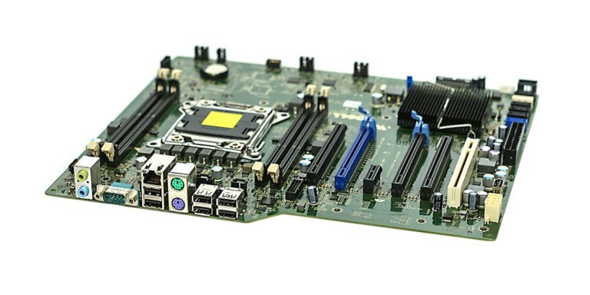RAM

CPU

PCI E SLOT SATA CONNETOR

* **12. Demonstrate how to install a RAM module into a computer.**
* **Answer -** To install a RAM module into a computer, you can follow these steps:
* Power off and disconnect: Make sure your computer is off and unplugged from any power source.
* Open the case: Open the computer’s case to access the motherboard. You might need a Phillips screwdriver and your owner’s manual.
* Ground yourself: Touch an unpainted metal surface to prevent static discharge from damaging the computer’s components.
* Locate the RAM slots: The RAM slots are usually near the central processing unit (CPU).
* Remove existing RAM: If there are existing RAM modules, you can release the clips on either side of the module and gently pull it out.
* Install the new RAM: Align the notch on the RAM stick with the ridge in the slot. Then, firmly press the RAM into the slot until the side clips snap into place. Apply even pressure across the top of the module.
* Reassemble: Reassemble the computer’s casing and plug all cords and accessories back in.

* **13. Discuss the importance of proper cooling mechanisms in a computer**

**System. Include examples of cooling methods and their effectiveness.**

* If all the components are dispersing heat into a small area, such as the inside of a PC case, the ambient temperature can quickly rise. If the case is not properly ventilated, the hot air can result in the system overheating, and performance can suffer as a result. That’s where airflow comes in.

**Example:-**

Air conditioning

Air cooling system

Immersion cooling

Cooling tower

Evaporative cooling

Air cooled chillers

* **14. Explain the concept of bus width and its significance in computer**

**Architecture.**

* In computer architecture, bus width is the amount of data that can be transferred at once during a memory read or write operation. Bus width is measured in bits, where a bit is a discrete one or zero state.
* A wider bus width means more data can be transferred per cycle, which allows the computer to process data faster. For example, if the data bus is increased from 32-bit to 64-bit, the computer can transfer twice as much information at once.
* The system bus, also known as the front side bus, connects the CPU to other components like memory and I/O devices. The width of the address bus affects how many memory locations can be addressed. A wider address bus allows the processor to access data and instructions from a larger main memory, which improves processor performance.